**DDC Vault User Manual**

**v1.0.0**

Contents

1. Instructions 3

2. Install the DDC Vault Extension： 4

2.1. Chrome Web Store 4

2.2. Microsoft Edge Extensions Home 5

2.3. Download Installation Package from the BSN Portal 7

3. Quick Start 8

3.1. First-time User 8

3.2. Create Password 8

3.3. Mnemonics 9

3.4. Unlock the DDC Vault 9

3.5. Signing 10

3.6. Reveal Private Key 10

3.7. Edit Chain Account Name and Remarks 11

3.8. Create Account 12

3.9. Import Account 12

3.10. Import the Account by Mnemonics 13

3.11. Forgot Password 14

3.12. View DDC Information 15

# Instructions

The DDC Vault is not a wallet, but an open-source tool designed to help users securely and independently store, manage and use their private keys in a convenient way, and to provide Platform Owners with a tool that can quickly meet their end-users' needs for managing and using private keys locally. The DDC Vault is not limited to providing DDC-based services, any functional scenarios that require private key signature can be integrated into it, such as non-password login, identity authorization, etc. Depending on different requirements, the DDC Vault supports three types of users:

**End-user**: End-users can create or import private keys into the DDC Vault, and it will store private keys securely in the user's local system. When end-users are required to use private keys, they can easily operate DDC Vault to use them.

**Website developer**: Developers can quickly integrate the DDC Vault into the website with their business in a simple and convenient way. They can also provide website users with features such as non-password login and automatic wake-up function of the DDC Vault for signature to improve user experience, and avoid the situation that users keep their own private keys but don’t know how to use them, resulting in the website being forced to keep users' private keys, thus causing a significant increase in mutual trust costs.

**Advanced developer**: The code of the DDC Vault will be completely open source, and developers with complex needs can quote the open-source code to build their own private key DDC Vault at will. You can also integrate your business into the DDC Vault, and we look forward to deep communication and cooperation with you.

This version of the DDC Vault extension supports following key features:

* **Creating accounts**
* **Importing and exporting private keys**
* **Signing**
* **Querying BSN-DDCs**

Since the signature mechanisms of different frameworks are not the same, this version of the DDC Vault is compatible with Wuhan Chain and Tai’an Chain. Other frameworks will be supported soon.

Due to the different development logic of extensions in different browsers, this version of the DDC Vault is compatible with Google Chrome and Microsoft Edge. Other browsers will be supported soon.

# Install the DDC Vault Extension：

The DDC Vault is already available in Chrome Web Store and Microsoft Edge Extensions Home, users can go to these stores to download and install. You can also download the installation package from the official BSN portal and install the extension through the developer mode of Chrome and Edge browsers. The installation process is as follows:

## Chrome Web Store

Open Chrome and find “Extensions” icon in the toolbar.

extension

Click on the icon to enter the Extension Management page. Click “Chrome Web Store” to access the store.

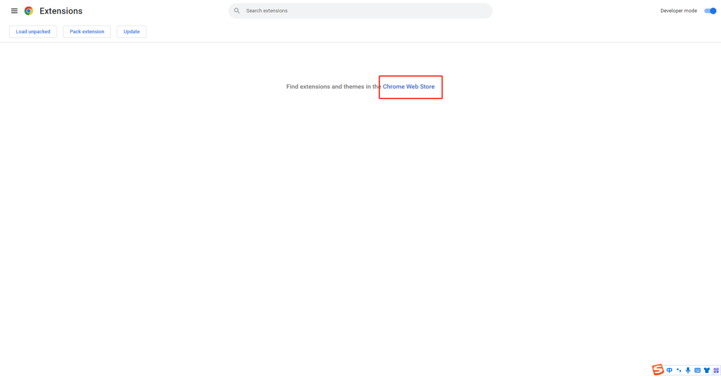

You can also find the store from the Extensions Menu on the top-left corner.

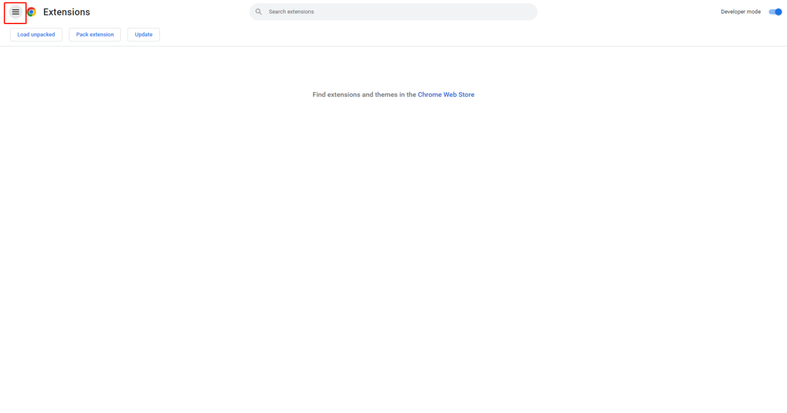

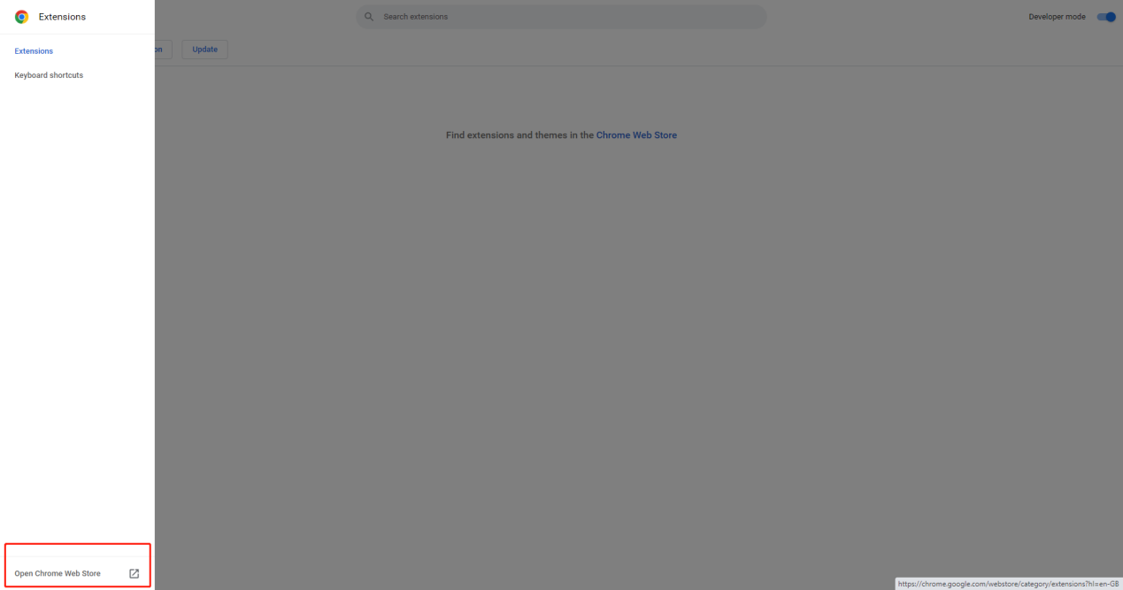

Search “DDC Vault” in the Chrome Web Store

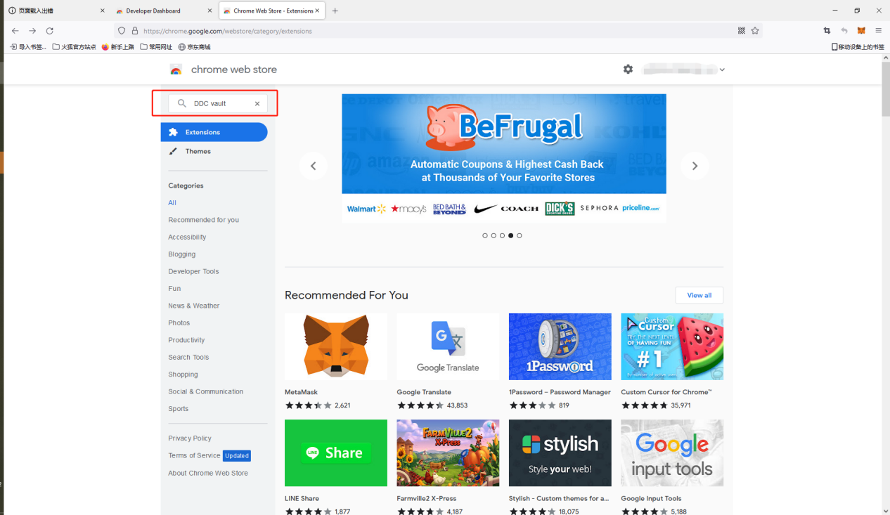

Click “Add to Chrome” to install the extension

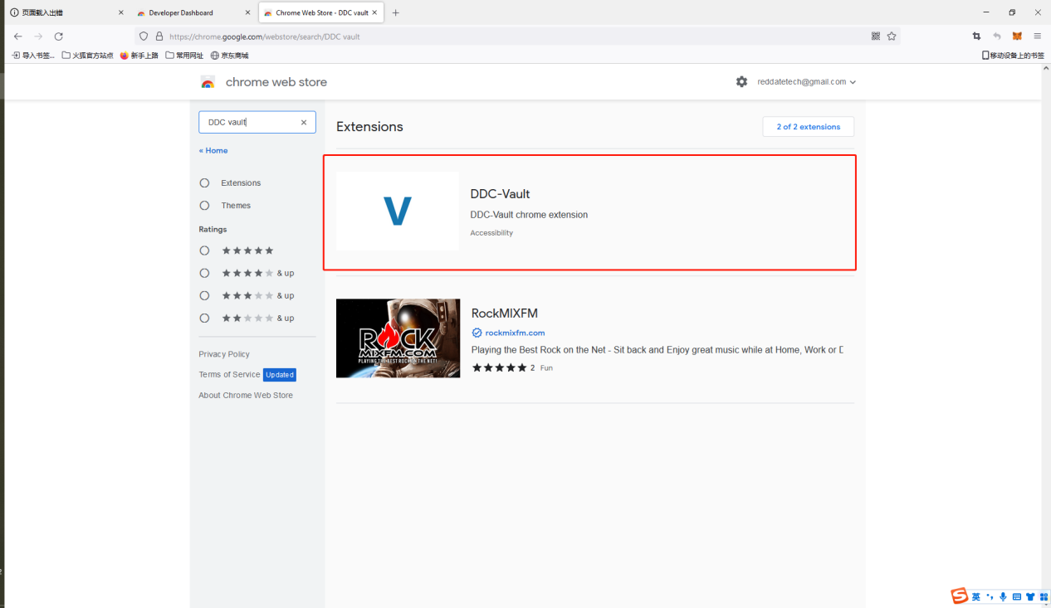

After installed the DDC Vault, you can find it in the Extensions page.

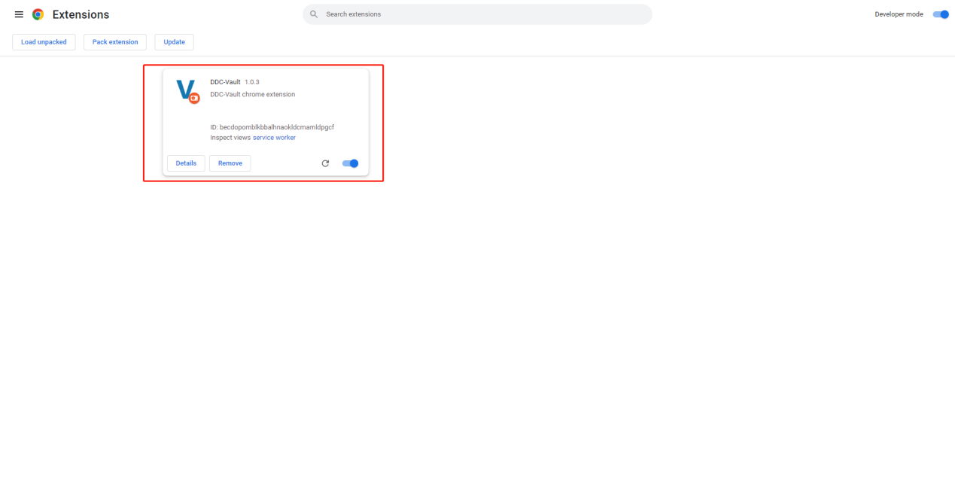

Click on the “Extensions” icon in the toolbar to open a drop-down menu, the DDC Vault extension will appear. Click the extension and open the DDC Vault page.

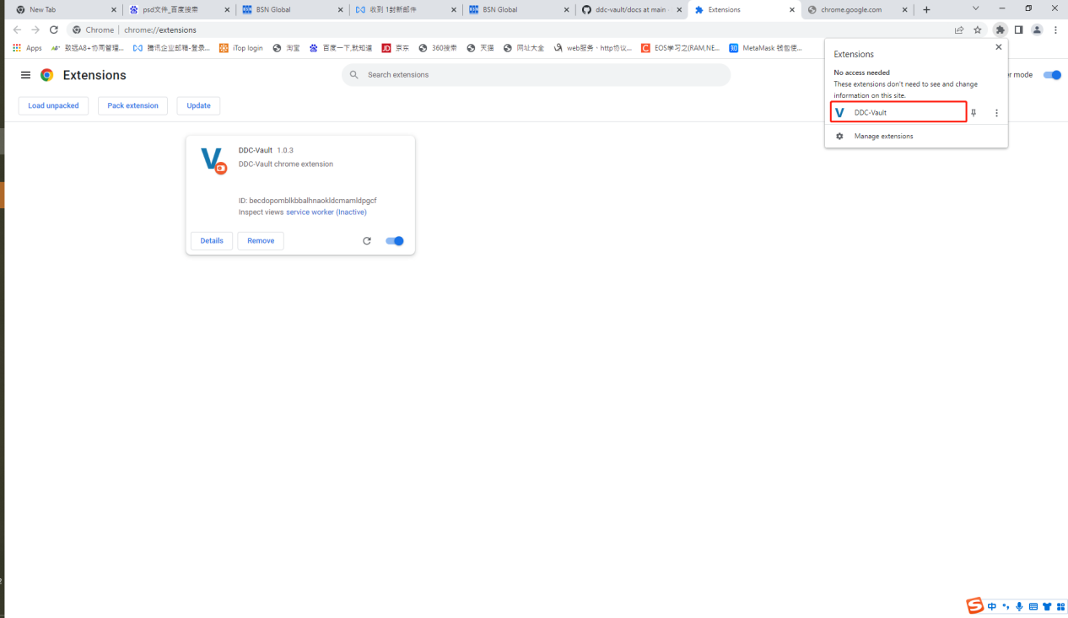

## Microsoft Edge Extensions Home

Open Microsoft Edge and click “Settings and more” icon in the toolbar.

edgemore

Click “Extensions” to show it in the toolbar.

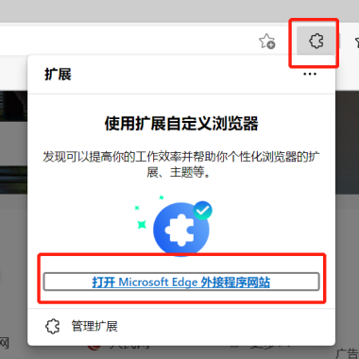

Click “Get extensions for Microsoft Edge” button to access Edge Add-ons page, and search “DDC Vault”

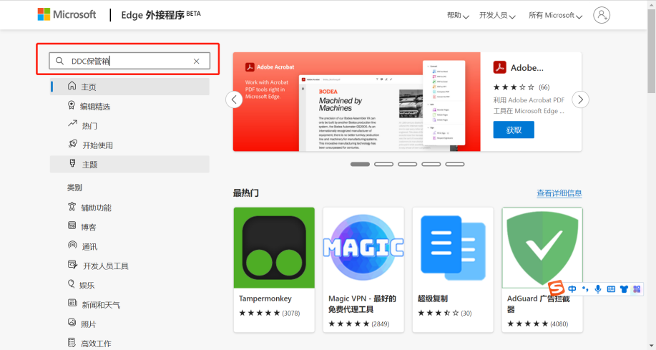

Find and install the DDC Vault extension

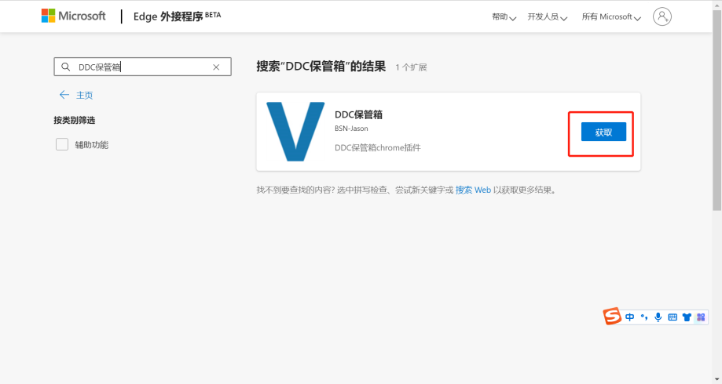

After installed the DDC Vault, you can find it in the Extension list in the toolbar. Click the extension and open the DDC Vault page.

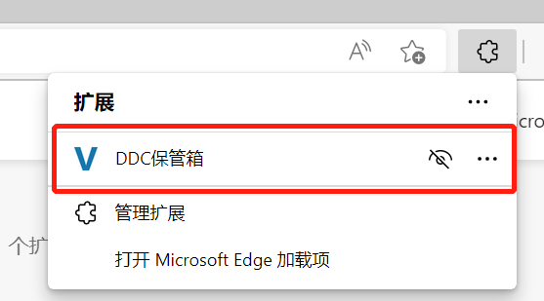

## Download Installation Package from the BSN Portal

Official download address:

<https://bsnbase.com/static/tmpFile/ddcVault.crx>

Open Chrome or Edge browser, access to the Extensions page from the toolbar, and enable the “Developer mode”

**Chrome**:



**Edge**:

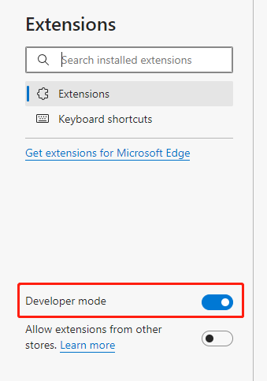

Click and drag the “ddcVault.crx” into the page.

**Chrome**:



**Edge**:

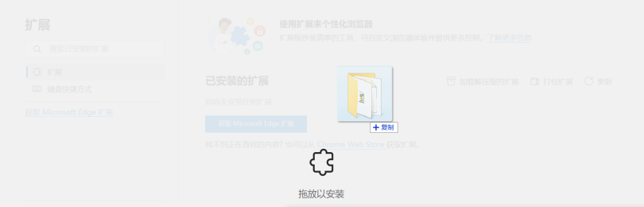

After installation, the DDC Vault icon will appear in the Extension Management page.

**Chrome**:

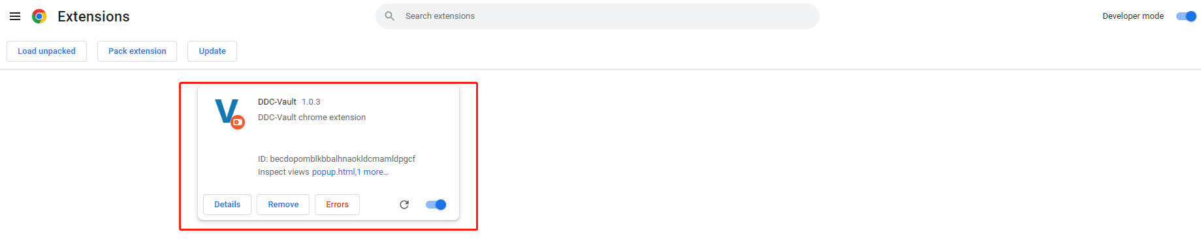

**Edge**:

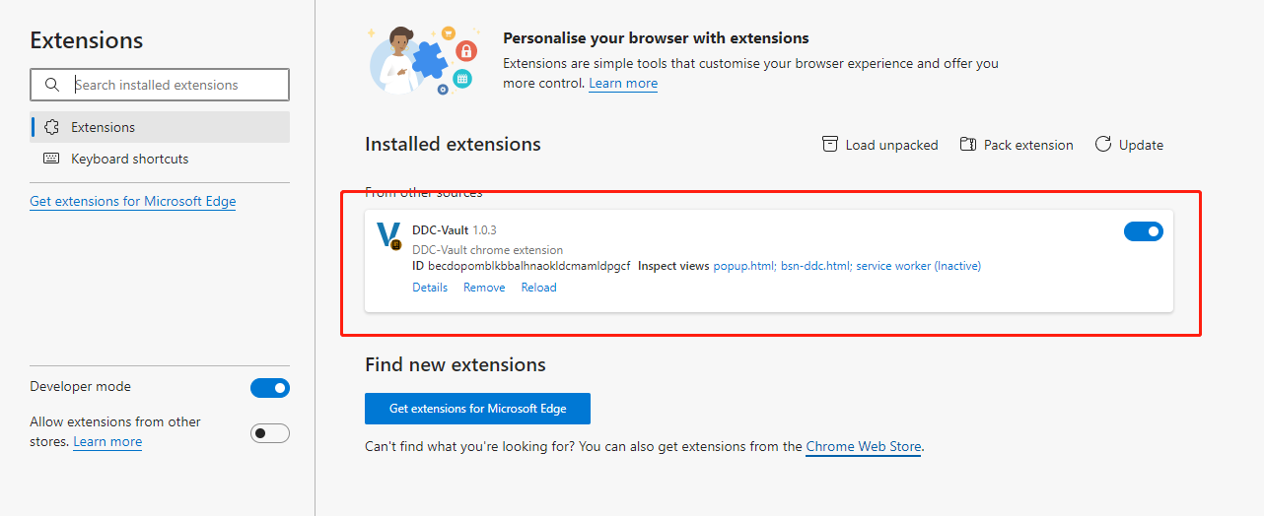

# Quick Start

## First-time User

Open the DDC Vault on the browser and click “Create a private key” button

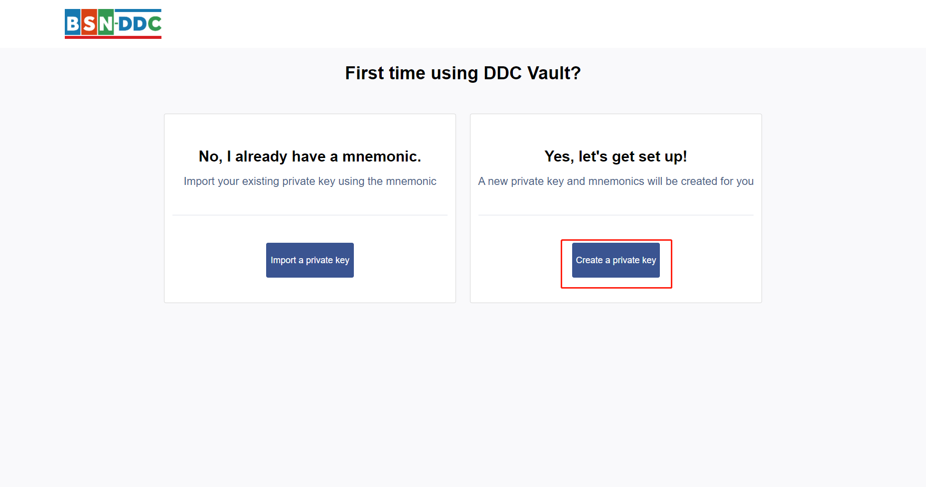

## Create Password

Enter the new password (at least 8 characters) and confirm the password. This password is used to unlock the extension when it is locked, please keep it safe. Read and agree to the Terms of Use and then click the “Create” button to create the password.

**Please note that DDC Vault will**:

Never collect your keys, addresses, transaction records, balances, hashes or any personal information;

Never collect your full IP address;

Never sell your data for profit.

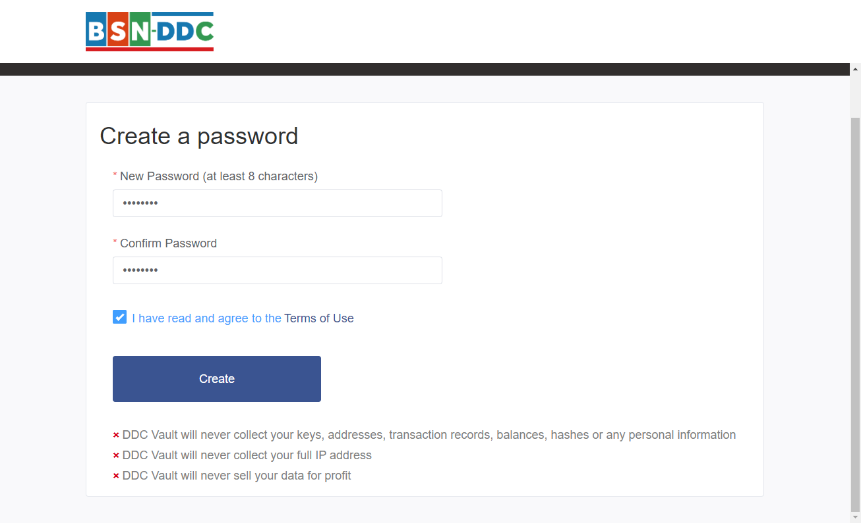

## Mnemonics

Mnemonics can help you recover the private key. However, the imported private keys cannot be recovered by the mnemonics generated here. Click on “Click here to reveal secret words” to get the mnemonic made of 12 English words. In case you are not satisfied with the generated mnemonic, you can click “Refresh Mnemonic” button to change the Mnemonic. Once confirmed the mnemonic, you can click and download it. Please keep it safe. Then click “Next” to the login page.

**Never disclose your mnemonic to others. Anyone with your mnemonic can completely control your DDC account.**

**Write this mnemonic on a piece of paper and keep it safe. If you want even more security, write it down on multiple pieces of paper and store each in 2 - 3 different locations.**

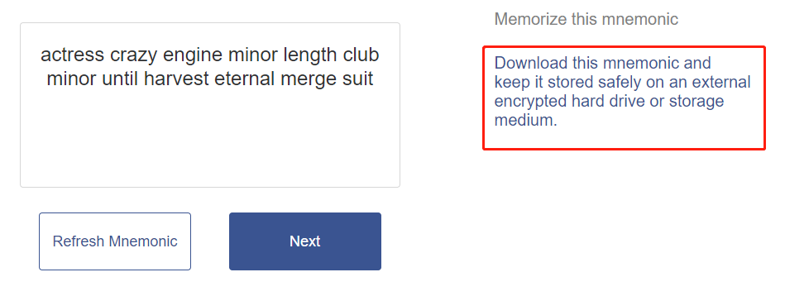

## Unlock the DDC Vault

After opening the DDC Vault and leaving it in an idle status for a moment, the DDC Vault will be locked. Then you should unlock it by inputting the password you created in chapter 3.2 Create Password.

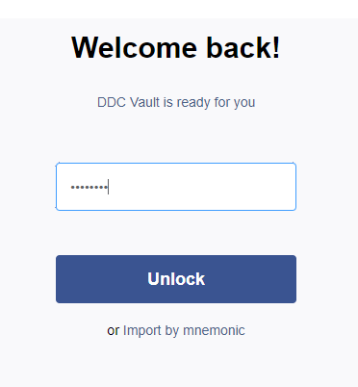

## Signing

If you want to sign the data by the private key in the “My Private Key List”, just find the address corresponding to the private key in the list, and click “Signing” button to open the signing page.

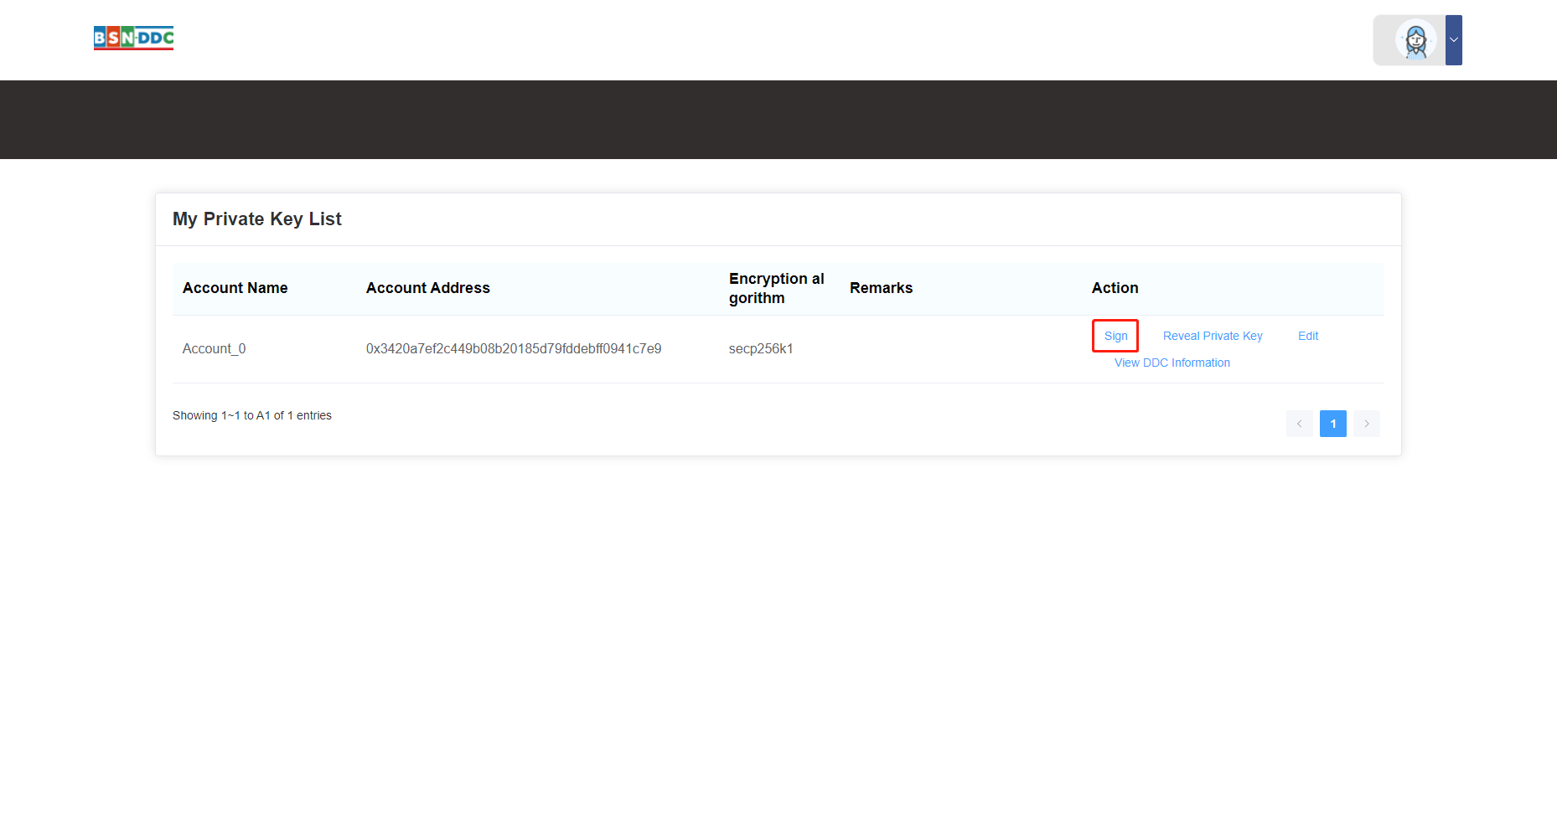

Input the data to be signed and the login password to get the signature.

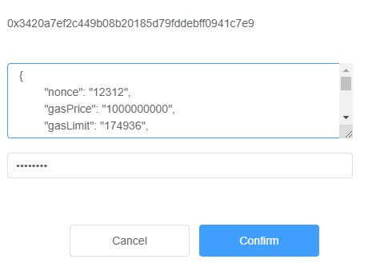

Click the “Copy” button to copy the signature.

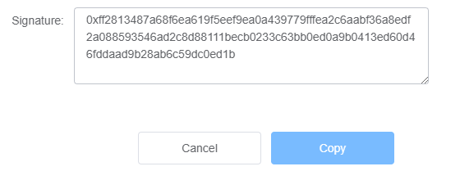

## Reveal Private Key

Click “Reveal Private Key” to view the private key of this chain account.

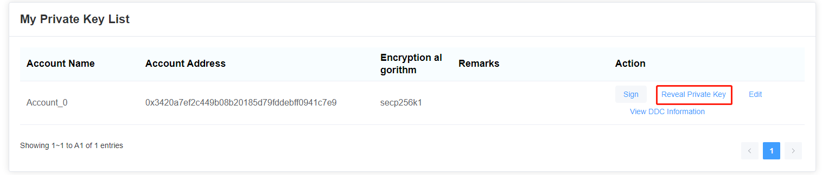

Input the login password to verify your authentication.

After verified, you can view the private key and click “Copy” button to get it.

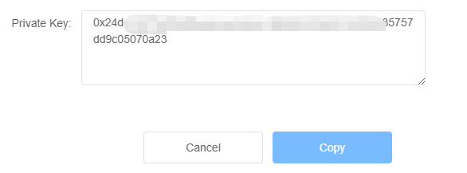

## Edit Chain Account Name and Remarks

Click “Edit” and open the Edit page.

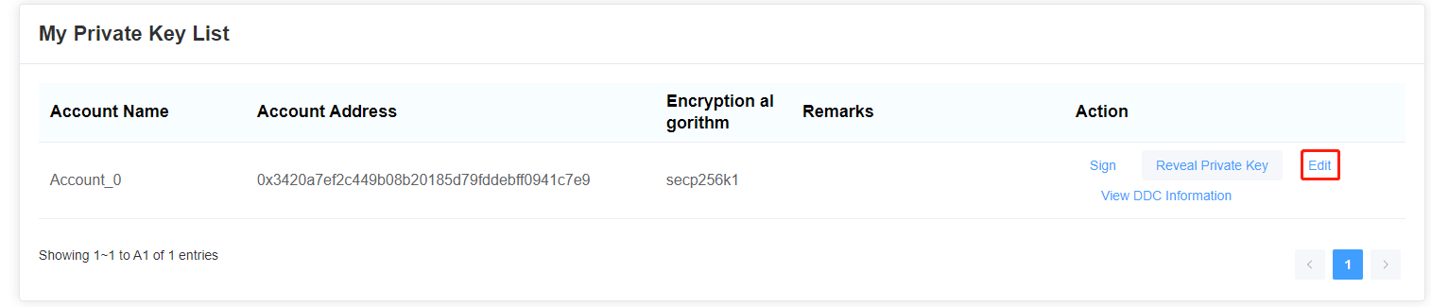

You can rename the chain account and update remarks.

Click “Confirm” button to save your edits.

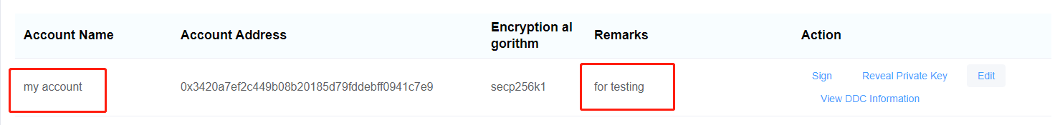

## Create Account

Click on the portrait icon on the top-right corner to list operations.

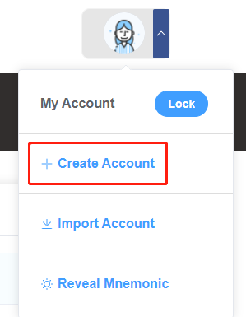

Click the “Create Account” button to open the “Create Account” window and fill in the information and login password.

Click “Confirm” button to create the chain account.

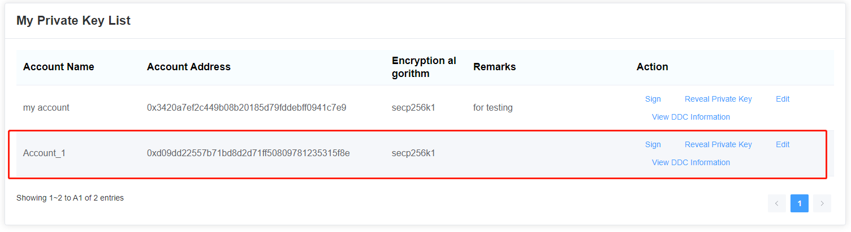

## Import Account

If you already have a private key and would like to use it here, you can import the key by clicking “Import Account”.

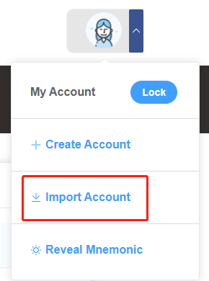

Open the “Import Account” window and fill in the information and login password.

Click “Confirm” button to import the private key.

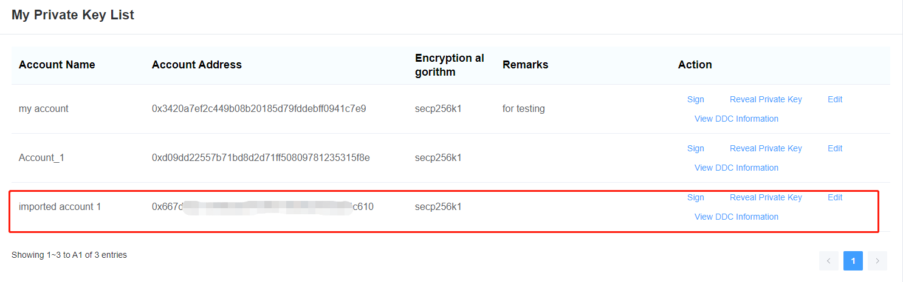

Note: The imported private key cannot be recovered by the mnemonic created by this user account, please keep it safe.

## Import the Account by Mnemonics

If you already have a mnemonic, you can recover your user account and all private keys by importing this mnemonic.

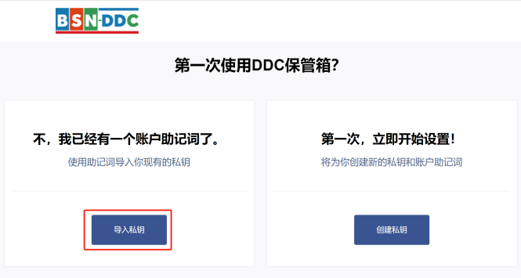

Fill in the mnemonic and login password, click to read and agree the Terms of Use.

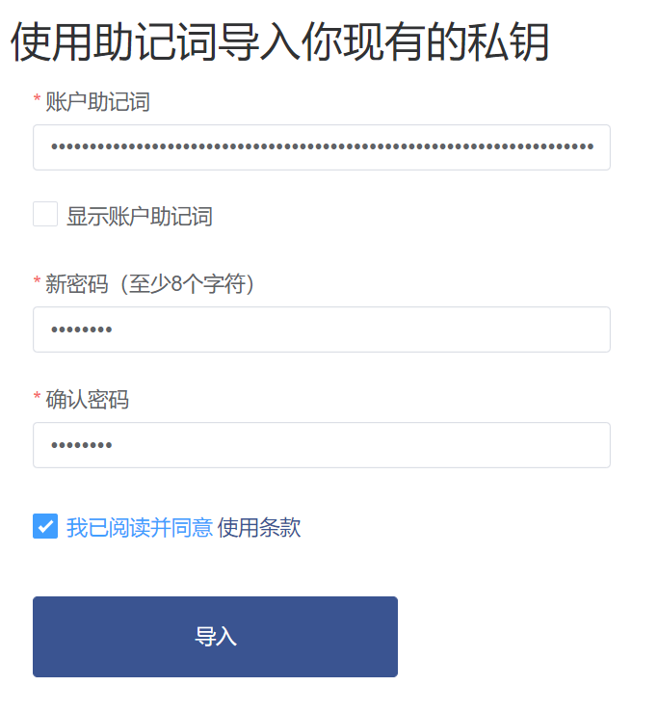

Click the “Import” button and login to the DDC Vault, you can see the chain accounts are on the list.

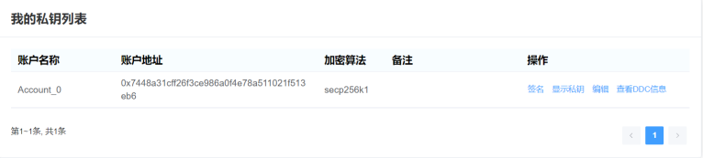

The mnemonic we are using here is the same with the one in the previous chapter, and we can see that the chain account address is successfully recovered on the list. If we want to recover the chain account created in chapter 3.8 Create Account, we just need to create a new account, and it shows the same information with the one created in chapter 3.8. However, the chain account imported in chapter 3.9 Import Account cannot be recovered, we can only re-import the private key to create such chain account.

## Forgot Password

In case you forgot your login password, you can choose “Import by mnemonic” to recover the user account. Then follow the same steps of 3.10 Import the Account by Mnemonics and retrieve the user account created by this mnemonic. The imported chain accounts cannot be recovered.

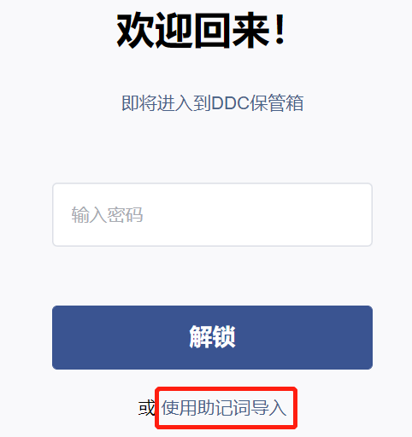

## View DDC Information

You can view the information of all DDCs in this user account by clicking “View DDC Information”



You can view all DDCs belonging to the current account

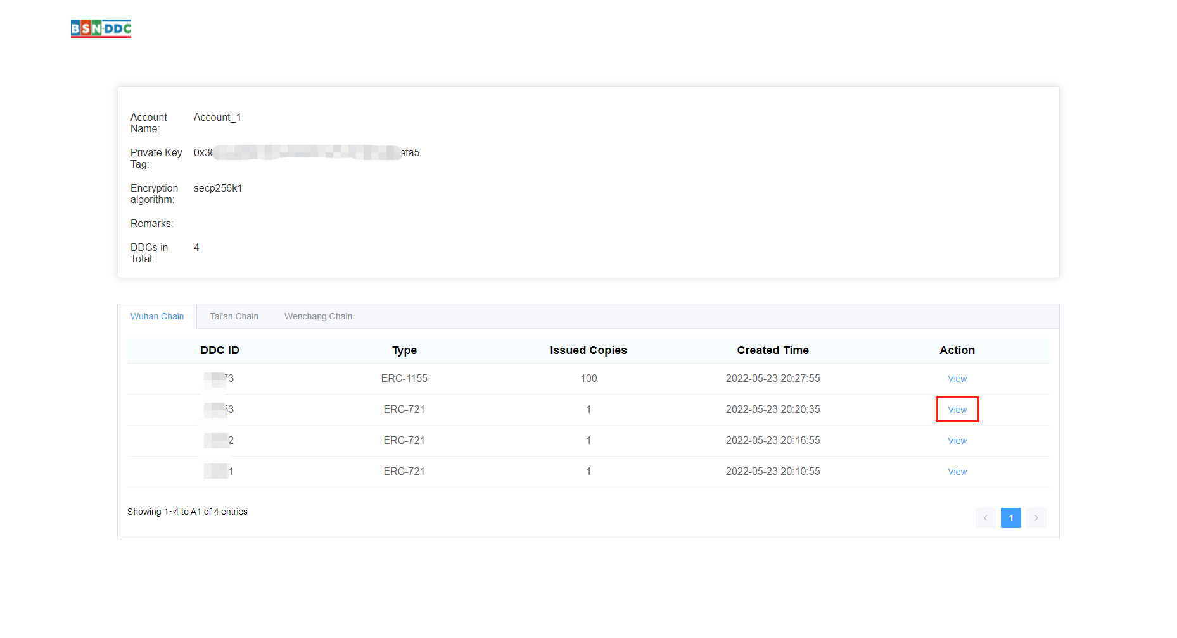

You can click ‘view’ to check the detailed information of each DDC and the transfer records

